EXPERIMENT 2.1:
Design and Performance Evaluation of a Chebyshev Type-I IIR Low-Pass Filter using MATLAB
clc; clear;

Wp=0.4; Ws=0.55; Rp=1; As=40;

[N,Wn]=cheb1ord(Wp,Ws,Rp,As);
[b,a]=cheby1(N,Rp,Wn);

fprintf('Filter Order = %d\n',N);
fprintf('Cutoff Frequency = %.2f * pi rad/sample\n',Wn);

if all(abs(roots(a))<1)
disp('System is STABLE');
else
disp('System is UNSTABLE');
end

% -------- GRAPHS --------
figure; freqz(b,a); % Magnitude + Phase
figure; impz(b,a); % Impulse Response
figure; grpdelay(b,a); % Group Delay
figure; zplane(b,a); % Pole-Zero

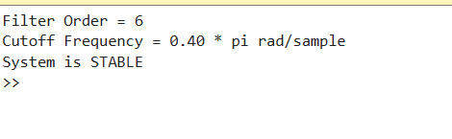
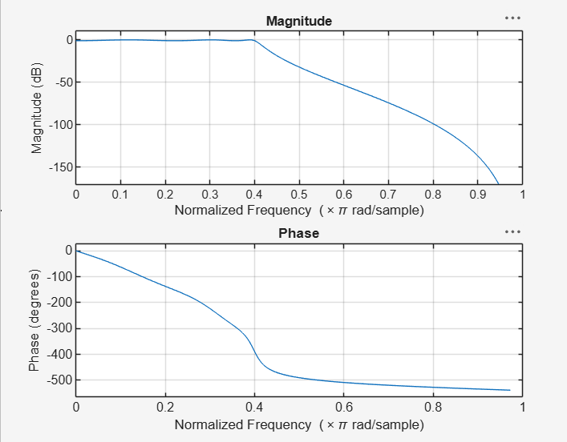
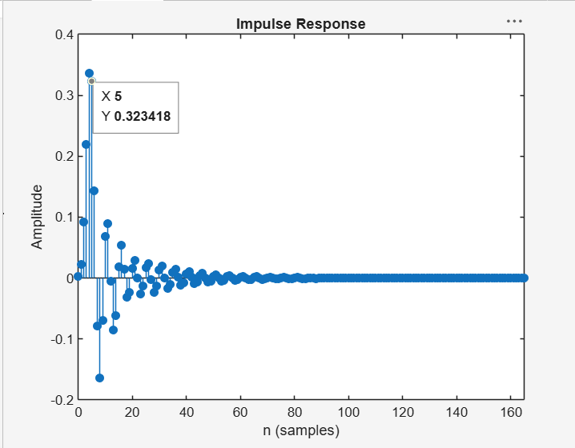

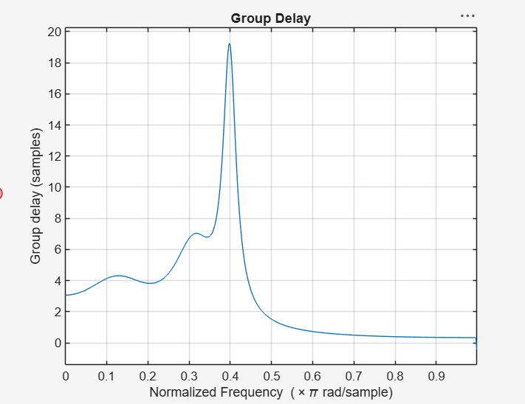

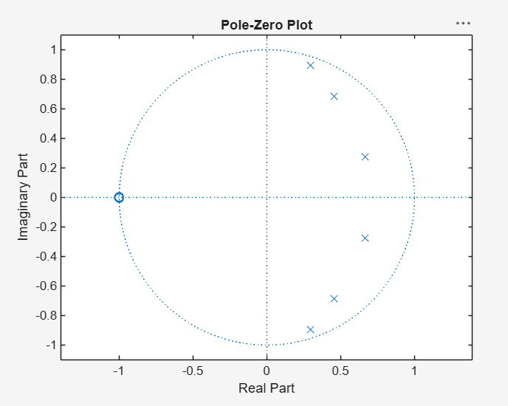

EXPERIMENT 2.2:
Design and Performance Evaluation of a Chebyshev Type-I IIR High-Pass Filter
clc;
clear;
close all;

% Specifications
Rp = 1; % Passband Ripple (dB)
Rs = 40; % Stopband Attenuation (dB)
Wp = 0.5; % Passband Edge

Ws = 0.35; % Stopband Edge

% Find Filter Order
[n,Wn] = cheb1ord(Wp,Ws,Rp,Rs);

% Design High-Pass Filter
[b,a] = cheby1(n,Rp,Wn,'high');

% Frequency Response
figure;
freqz(b,a);
title('Frequency Response');

% Impulse Response
figure;
impz(b,a);
title('Impulse Response');

% Group Delay
figure;
grpdelay(b,a);
title('Group Delay');

% Pole-Zero Plot
figure;
zplane(b,a);
title('Pole-Zero Plot');

fprintf('Filter Order = %d\n',n);

fprintf('Cutoff Frequency = %.4f\n',Wn);

